Perimetru PowerPlay low-cost

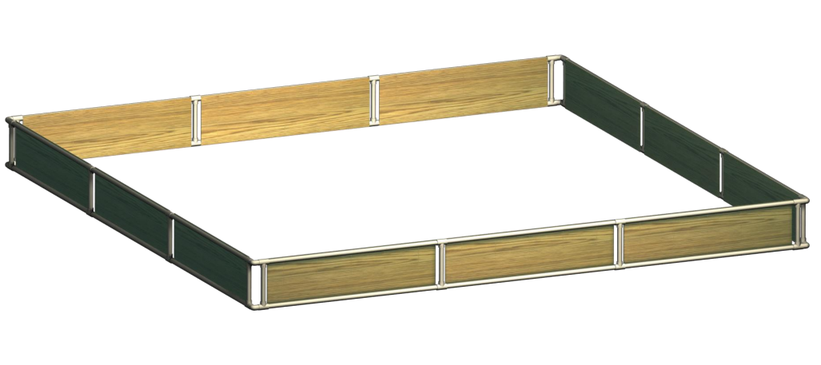
Magazin | Nr.Crt | Descriere | Cantitate | Pret Est./per unit | Pret Total
Mathaus Vitan | 1 | TEU PP-R 025 FORMUL | 32 | RON 0.68 | RON 21.76
Mathaus Vitan | 2 | COT PP-R 90/025 SUPRA | 8 | RON 0.73 | RON 5.84
Mathaus Vitan | 3 | TEAVA PP-R PN 10x25 MM FORMUL 6M(NEVOIE:32METRI) | 6 | RON 14.13 | RON 84.78
Brico Depot Vitan | 4 | OSB 2500mm x 1250mm x 8mm | 2 | RON 64.50 | RON 129.00
Brico Depot Vitan | 5 | Taiere OSB(Primele 2 taieturi de pe fiecare placa sunt gratis) | 6 | RON 3.00 | RON 18.00
Brico Depot Vitan |  |  |  | Pret Total: | RON 259.38
Mathaus Vitan | https://goo.gl/maps/dK5xSCjpR7UCZx2n8
Brico Depot Vitan | https://goo.gl/maps/JJEr1VHN6v3rwHH68

